**Practical:8**

**Aim: ERP-Module description.**

opentaps Delivers as Supply Chain Solution for Honeywell International.

Honeywell International (NYSE: HON) is responsible for providing spare parts, repair, and maintenance services to both commercial airlines and governments. In one project for the United States government, Honeywell provides complete repair and maintenance services for the engine of a major vehicle system for the United States Department of Defense. This includes maintaining an adequate supply of the engine and its spare parts both in the field and at four maintenance depots around the world over the entire multi-year contracted time period.

 Honeywell use the opentaps Open Source ERP + CRM system and leverage its existing supply chain management features for inventory planning, instead of rebuilding its custom models from scratch.

**Purchasing and Supply Chain Management**

* Manage Suppliers records, including contact information
* See real time inventory
* Automate production and purchasing calendar with Material Resources Planning (MRP)
* Use requirements to streamline purchasing work flow
* Support for Value Added Taxes (VAT) through [VAT module](http://shop.opentaps.org/index.php/featured/vat-module-by-integratingweb.html)

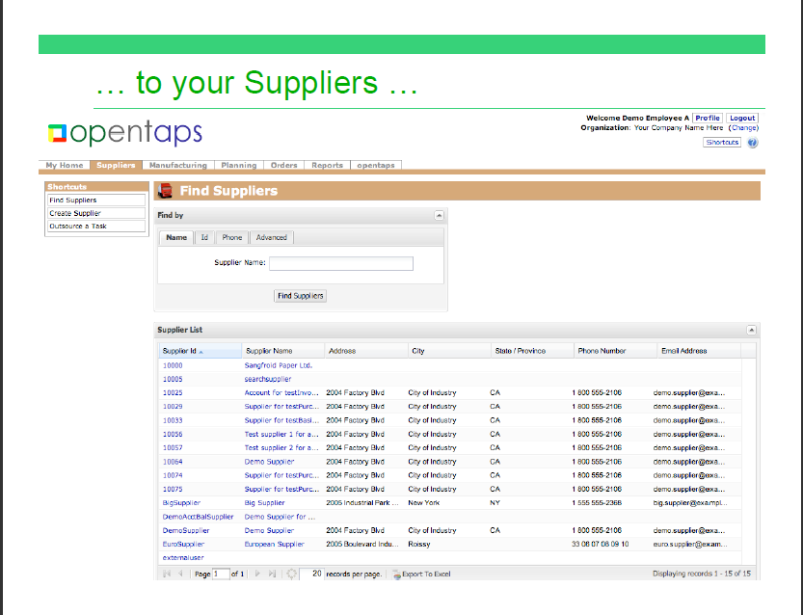

Supply Chain Management module